Indian Railway Schedule Analytics
HEMA
I MSc Data Science
Department of Computer and Information Science, Annamalai University, Chidambaram

AGENDA
1. OVERVIEW 1
2. OBJECTIVE 1
3. DATASET AND DESCRIPTION 1
4. TOOLS AND TECHNOLOGY USED 2
5. PROJECT WORKFLOW 2
6. SAMPLE INSIGHTS 3
7. VISUALIZATION 3
8. KEY FINDINGS 10
9. CHALLENGES FACED DURING DATA ANALYSIS 11
10. CONCLUSION 12
11. REFERENCES 12

1. OVERVIEW
Railway transport is one of the most widely used modes of public transportation in India, serving millions of passengers every day across a vast geographical area. This project focuses on studying and understanding the structure and operational patterns of the Indian railway network by analysing a large schedule dataset collected from Kaggle. The main goal is to find out how train traffic is distributed across stations, how arrivals and departures vary through the day, and what patterns exist in journey duration and route distance.
The dataset used for this project contains 417,080 schedule records, combining information from three sources — Schedules, Trains, and Stations — into a single merged file of 34 columns. This data was used to clean, explore, and visualize the operational characteristics of the Indian railway network.

2. OBJECTIVE
The objective of this project is to analyse Indian railway schedule data and understand the factors that influence station traffic, train stop patterns, and daily arrival/departure activity across the network. The project focuses on merging the schedule, train, and station datasets, cleaning the combined data, and performing exploratory data analysis using Python and its analytical libraries such as Pandas, Matplotlib, and Seaborn.
By presenting the results through clear charts, the project enables easy interpretation of how train traffic is distributed across stations, which trains and routes are the busiest or longest, and how train activity changes throughout the day. This approach provides an efficient way to study the operational structure of a large railway network and supports data-driven thinking for further analytical work.

3. DATASET AND DESCRIPTION
The dataset used in this project was obtained from Kaggle, which provides comprehensive information on Indian railway schedules. Three separate datasets — Schedules, Trains, and Stations — were merged into a single CSV file named Merged Railway Dataset.csv. The merged dataset includes 417,080 records and 34 columns, combining schedule-level timing information with train and station metadata, such as train number, train name, arrival and departure times, distance, train type, train zone, station name, station state, station zone, and geographic coordinates.
This dataset allows for analysis of station-level traffic, train stop frequency, time-of-day arrival and departure patterns, and the distribution of route distances and journey days across the network. Structured in CSV format, it is suitable for data preprocessing, exploratory analysis, and visualization using Python libraries such as Pandas, Matplotlib, and Seaborn.

4. TOOLS AND TECHNOLOGY USED
This project utilizes Python as the primary programming language due to its simplicity and powerful data analysis libraries. For data manipulation and preprocessing, Pandas was used extensively, while Matplotlib and Seaborn were used for data visualization. Jupyter Notebook served as the development environment for coding, testing, and documenting the analysis. CSV files were used for storing and handling both the merged input dataset and the cleaned output dataset.
- Python – core programming language used for all data processing and analysis.
- Jupyter Notebook – interactive environment used for writing, executing, and documenting the analysis.
- Pandas – used for reading the dataset, cleaning, handling missing values, removing duplicates, type conversion, and aggregation.
- Matplotlib – used for bar charts, line charts, pie charts, and histograms.
- Seaborn – used for the distance distribution plot and the arrivals/departures heatmap.

5. PROJECT WORKFLOW
- Import the merged railway dataset (CSV), and inspect its shape, structure, and data types.
- Identify and handle missing values; remove duplicate records; verify and convert data types for time and numeric columns.
- Compute summary statistics such as the number of unique trains and unique stations.
- Analyse station-level traffic, train stop frequency, and journey-day distribution.
- Analyse arrival and departure patterns across the 24-hour day, and study route distance characteristics.
- Summarize findings, present visual results, and export the cleaned dataset for reuse.

6. SAMPLE INSIGHTS
The analysis of the railway schedule data shows several clear patterns. Train traffic is concentrated at a small number of major junction stations, with Sabarmati Junction, Kanpur Central, Itarsi Junction, Ghaziabad, and Sahibabad emerging as the busiest stations in the network. Among individual trains, the Garib Nawaz Express has the highest number of scheduled stops, while suburban EMU services such as the Chennai Beach Velachery EMU also rank highly due to their many closely spaced local halts.
Train arrivals are heavily concentrated in the early morning between 4 a.m. and 6 a.m., while departures show two extreme peaks — one at 6 a.m. and another at 11 p.m. Both arrivals and departures are at their lowest between midnight and 3 a.m. The majority of train journeys (over 95% of records) are completed within the first two scheduled days, and route distances are multi-modal, with large clusters of short routes (0–500 km) and medium-distance routes (1,300–2,000 km). The Kanniyakumari–Dibrugarh Vivek Express is the longest route in the dataset at approximately 4,280 km.

7. VISUALIZATION
This section presents the eight visualizations developed during the exploratory analysis of the cleaned railway dataset. Each visualization includes its objective, the reason for choosing that chart type, an explanation of the graph, the observations drawn from it, the insight derived, and the importance of the result.

7.1 Top 5 Busiest Stations
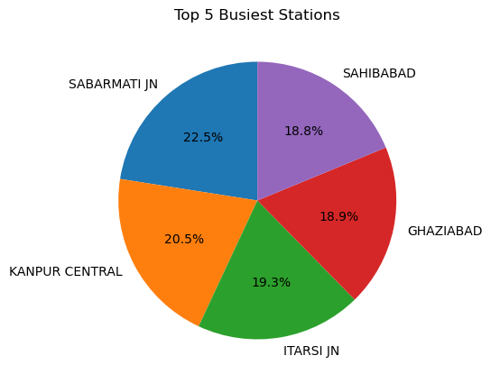
Figure 7.1: Top 5 Busiest Stations
Objective:
To identify the five railway stations with the highest number of scheduled stops and understand their relative share of traffic.
Why This Visualization Was Created:
A pie chart was selected because it effectively communicates the proportional share of each of the top five stations relative to one another.
Explanation of the Graph:
The chart was generated by counting occurrences of each station_name using value_counts(), selecting the top five, and plotting their relative shares with percentage labels.
Observation:
Sabarmati Junction accounts for the largest share (about 22.5%), followed by Kanpur Central (about 20.5%), Itarsi Junction (about 19.3%), Ghaziabad (about 18.9%), and Sahibabad (about 18.8%). The five stations are relatively close in share.
Insight:
Traffic at the busiest stations is not concentrated at a single mega-hub but spread across several major junctions on different trunk routes.
Importance of the Result:
Identifying the busiest stations is important for infrastructure planning, platform capacity, and scheduling decisions.

7.2 Top 10 Trains with Most Stops
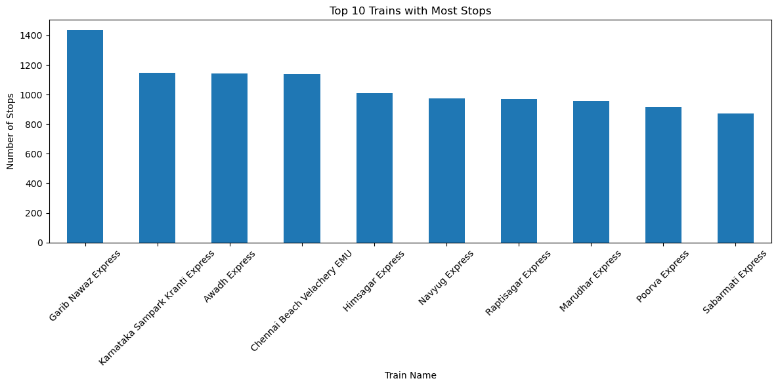
Figure 7.2: Top 10 Trains with Most Stops
Objective:
To identify the ten trains with the highest number of scheduled stops across their entire route.
Why This Visualization Was Created:
A vertical bar chart was used because it allows clear, ordered comparison of stop counts across multiple trains.
Explanation of the Graph:
The dataset was grouped by train_name, the number of station_code entries per train was counted, sorted in descending order, and the top ten plotted as bars.
Observation:
The Garib Nawaz Express has the highest stop count (about 1,430), followed closely by the Karnataka Sampark Kranti Express, Awadh Express, and Chennai Beach Velachery EMU (about 1,140–1,150). The remaining trains range from about 875 to 1,010 stops.
Insight:
Trains with very high stop counts are typically long-distance mail/express services or suburban EMU services serving many closely spaced stations.
Importance of the Result:
Understanding stop-heavy trains helps evaluate journey efficiency and supports timetable optimization decisions.

7.3 Train Arrivals by Hour
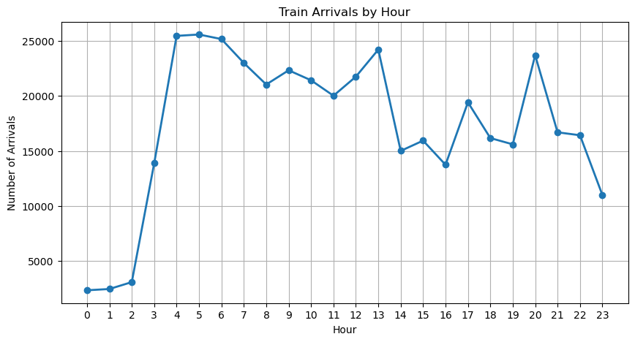
Figure 7.3: Train Arrivals by Hour
Objective:
To analyse how train arrivals are distributed across the 24 hours of the day.
Why This Visualization Was Created:
A line chart was chosen because it shows the trend and fluctuation of arrival counts across ordered hours clearly.
Explanation of the Graph:
Arrival timestamps were converted to datetime format, the hour was extracted, and arrival counts per hour were plotted from 0 to 23.
Observation:
Arrivals are lowest between midnight and 2 a.m. (about 2,300–3,100), rising sharply to a sustained peak between 4 a.m. and 6 a.m. (about 25,000–25,600), with secondary peaks near 1 p.m. and 8 p.m.
Insight:
Early morning is the dominant arrival window, suggesting many overnight long-distance trains are scheduled to reach destinations before dawn.
Importance of the Result:
Recognising the early-morning concentration helps in planning staffing and platform availability at stations.

7.4 Train Departures by Hour
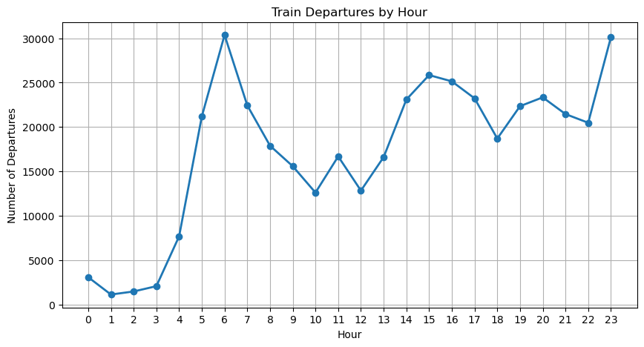
Figure 7.4: Train Departures by Hour
Objective:
To analyse how train departures are distributed across the 24 hours of the day.
Why This Visualization Was Created:
A line chart was used to visualize the hourly departure trend and compare it with the arrival pattern.
Explanation of the Graph:
Departure timestamps were converted to datetime format, the hour extracted, and departure counts per hour plotted across the day.
Observation:
Departures are extremely low between 1 a.m. and 3 a.m. (about 1,100–2,200), then peak sharply at 6 a.m. (about 30,400) and again at 11 p.m. (about 30,200), the two highest values in the dataset.
Insight:
Indian Railways concentrates a large share of train originations at the start of the day and late at night, consistent with overnight and early-day scheduling.
Importance of the Result:
These sharp peaks are important for understanding platform turnaround and staffing needs at originating stations.

7.5 Distribution of Station Stop Frequency
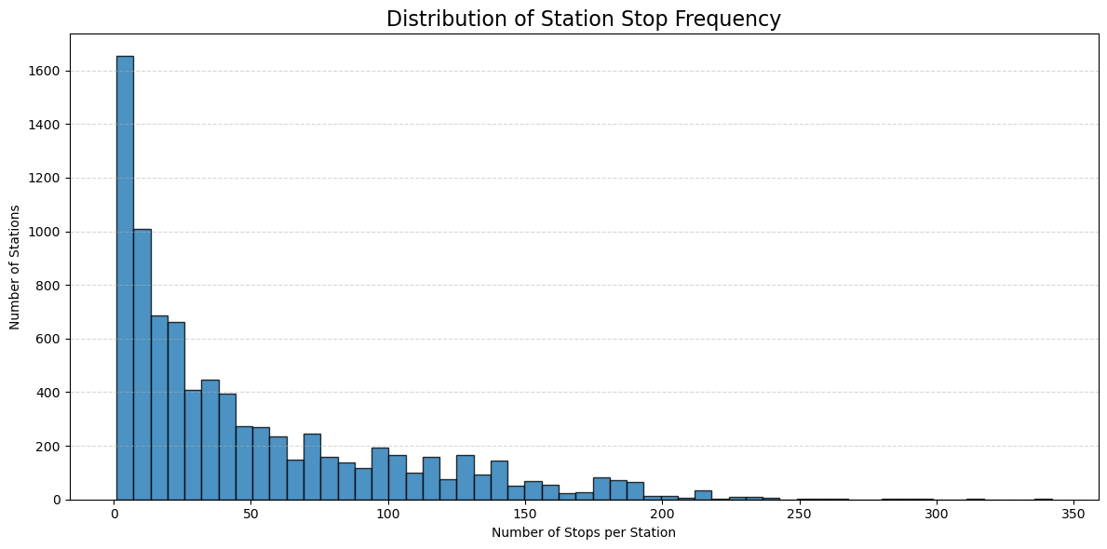
Figure 7.5: Distribution of Station Stop Frequency
Objective:
To examine how scheduled stop counts are distributed across all stations.
Why This Visualization Was Created:
A histogram was used because it displays the frequency distribution of stop counts across a large number of stations clearly.
Explanation of the Graph:
Stations were grouped, the number of records (stops) per station counted, and the distribution plotted with automatic bin widths.
Observation:
Roughly 1,650 stations have very low stop counts, with frequency decreasing sharply as stop count rises; a long tail extends to 250–300+ stops for a handful of stations.
Insight:
Most stations handle relatively few stops, while a small number of major junctions handle a disproportionately large share — a hub-and-spoke structure.
Importance of the Result:
This confirms that infrastructure investment should be prioritised at a small number of high-traffic junctions.

7.6 Train Stops by Journey Day
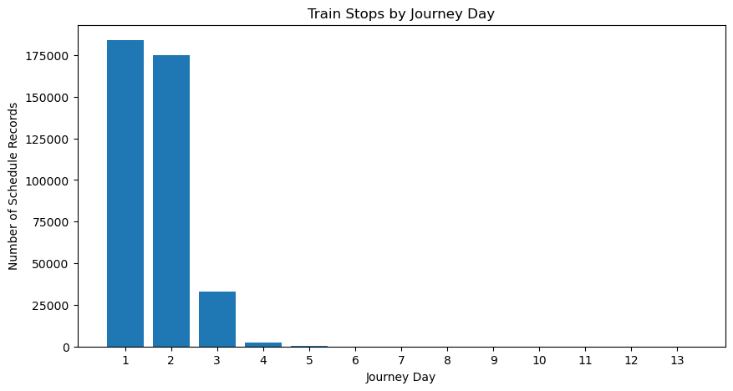
Figure 7.6: Train Stops by Journey Day
Objective:
To understand how scheduled stops are distributed across the days of a train's journey.
Why This Visualization Was Created:
A bar chart was used since schedule_day is a discrete, ordered category, making the decline across days easy to see.
Explanation of the Graph:
schedule_day was converted to numeric form, counts per day computed, and plotted as bars ordered by day number.
Observation:
Day 1 (183,993) and Day 2 (174,878) dominate, dropping sharply at Day 3 (32,888) and Day 4 (2,591), with negligible counts beyond Day 5 through Day 13.
Insight:
Most journeys complete within one to two days; only a small fraction of long-haul trains extend to three or more days.
Importance of the Result:
This distinguishes regular services from long-haul trains needing special multi-day operational planning.

7.7 Distribution of Train Route Distances
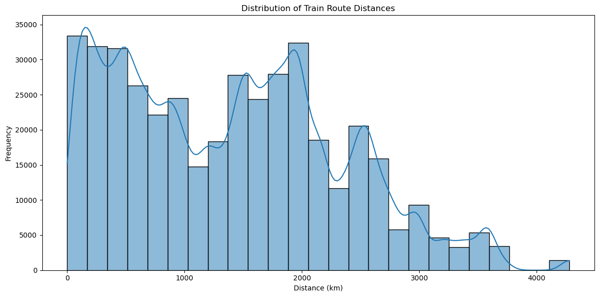
Figure 7.7: Distribution of Train Route Distances
Objective:
To study how train route distances are distributed across the network.
Why This Visualization Was Created:
A histogram with a kernel density estimate (KDE) was used to show both binned frequency and overall distribution shape.
Explanation of the Graph:
The distance column was converted to numeric form, missing values excluded, and plotted as a 25-bin histogram with a KDE overlay.
Observation:
A large concentration of routes falls within 0–500 km (about 30,000–34,000 frequency), with a second concentration at 1,300–2,000 km (about 28,000–32,000); frequencies decline beyond 2,500 km, with very few routes beyond 3,500 km.
Insight:
The multi-modal shape suggests distinct categories of services — short/suburban, medium inter-state express, and a small number of very long-distance routes.
Importance of the Result:
This distance profile is useful for fleet planning, since different distance categories need different coach and crew arrangements.

7.8 Top 10 Longest Distance Trains
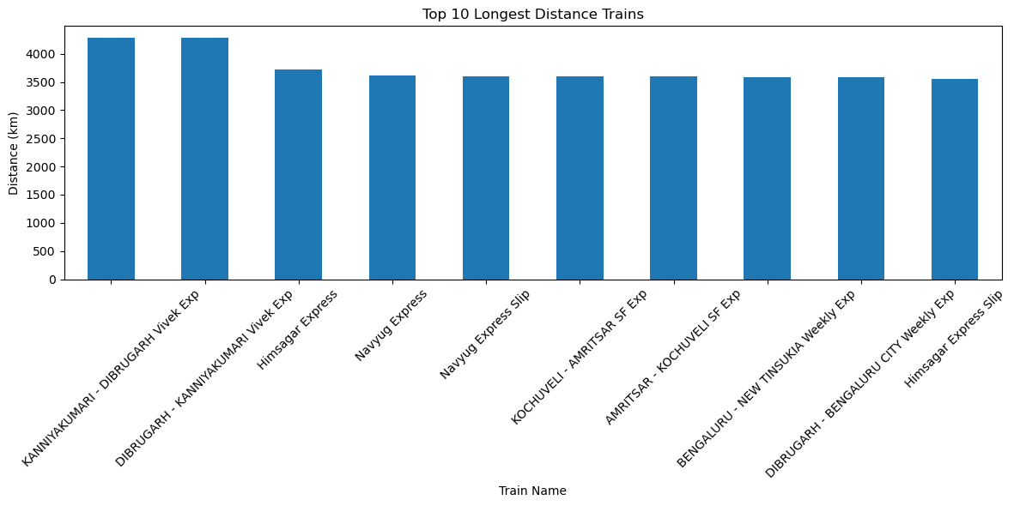
Figure 7.8: Top 10 Longest Distance Trains
Objective:
To identify the ten trains that cover the greatest route distances.
Why This Visualization Was Created:
A vertical bar chart was used for direct, ordered comparison of maximum distance per train.
Explanation of the Graph:
The dataset was grouped by train_name, the maximum distance extracted, sorted in descending order, and the top ten plotted as bars.
Observation:
The Kanniyakumari–Dibrugarh Vivek Express and its return service lead at about 4,280 km, followed by the Himsagar Express (about 3,730 km) and a cluster of trains between about 3,560 and 3,620 km, including the Navyug Express, Kochuveli–Amritsar SF Express, and Bengaluru–New Tinsukia Weekly Express services.
Insight:
The longest routes connect geographically distant regions of India, reflecting their role in providing direct cross-country connectivity.
Importance of the Result:
Identifying the longest-running trains is important for crew rotation, catering, and maintenance planning across multiple railway zones.

7.9 Train Activity by Hour: Arrivals vs Departures (Heatmap)
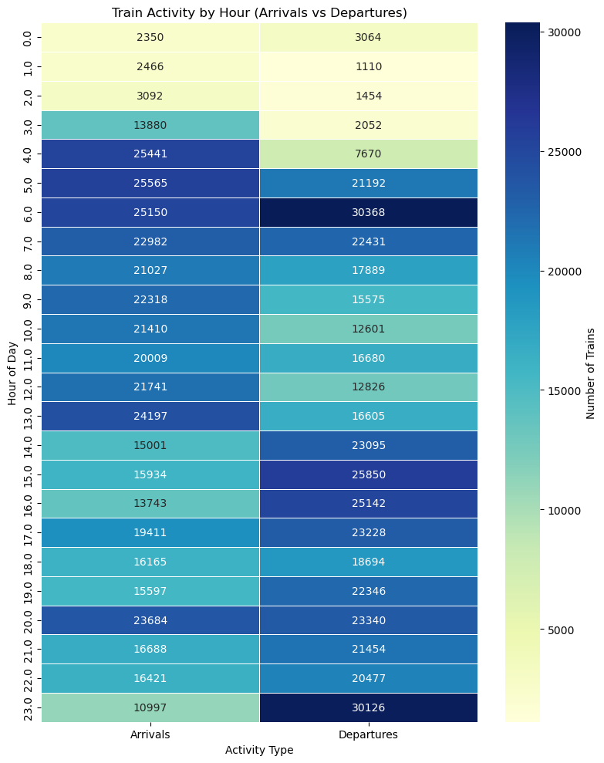
Figure 7.9: Heatmap of Train Activity by Hour (Arrivals vs Departures)
Objective:
To present a combined, side-by-side comparison of hourly arrival and departure counts in a single visualization.
Why This Visualization Was Created:
A heatmap with annotated values was used so two related time-series (arrivals and departures) could be compared simultaneously across all 24 hours.
Explanation of the Graph:
Hourly arrival and departure counts were combined into one table with hours as rows and Arrivals/Departures as columns, rendered as a heatmap with darker shades indicating higher activity.
Observation:
The darkest cells correspond to departures at 6 a.m. (30,368) and 11 p.m. (30,126). Arrivals peak between 4–6 a.m. (about 25,000–25,600), while the lightest cells occur for arrivals between midnight and 2 a.m. and departures between 1 a.m. and 3 a.m.
Insight:
Arrivals and departures follow distinct but complementary daily rhythms, with early morning (4–6 a.m.) standing out as the busiest combined window of the day.
Importance of the Result:
This combined view helps identify the early-morning hours as the period requiring the highest platform availability and staffing coordination.

8. KEY FINDINGS
- The cleaned and merged dataset contains 417,080 schedule records spanning 5,208 unique trains and 8,539 unique stations.
- Columns such as station_state, station_zone, and station_address had over 300,000 missing values each, reflecting incomplete station metadata.
- After cleaning — removing duplicates and filling missing values with “Unknown” — the dataset had zero remaining nulls.
- Sabarmati Junction is the busiest station among the top five (about 22.5% share), followed by Kanpur Central, Itarsi Junction, Ghaziabad, and Sahibabad.
- The Garib Nawaz Express has the highest number of scheduled stops of any train, at about 1,430.
- Several high-stop trains, such as the Chennai Beach Velachery EMU, are suburban services rather than long-distance expresses.
- Train arrivals peak sharply between 4 a.m. and 6 a.m. (about 25,000–25,600 per hour).
- Train departures peak at 6 a.m. (about 30,400) and again at 11 p.m. (about 30,200), the two highest hourly values recorded.
- Both arrivals and departures are lowest between midnight and 3 a.m.
- Station stop frequency is strongly right-skewed: about 1,650 stations have very low stop counts, while a few major junctions reach 250–300+ stops.
- This skew confirms a hub-and-spoke structure in the Indian railway network.
- Over 95% of journeys are completed within the first two scheduled days (Day 1: 183,993; Day 2: 174,878 records).
- Only a small number of journeys extend beyond Day 3, becoming negligible after Day 5.
- Route distances follow a multi-modal distribution, with large clusters at 0–500 km and 1,300–2,000 km.
- Routes beyond 3,500 km are rare, indicating ultra-long-distance services form a small fraction of all trains.
- The Kanniyakumari–Dibrugarh Vivek Express and its return service are the longest routes in the dataset (about 4,280 km).
- Several long-distance trains operate in matched outbound/return pairs, confirming route symmetry in scheduling.
- The combined heatmap confirms early morning (4–6 a.m.) as the single busiest period for both arrivals and departures.
- There is a wide gap between the busiest stations/trains and the long tail of low-traffic stations/trains.
- Systematic cleaning and visualization revealed clear, actionable structural patterns even in a very large, initially messy dataset.

9. CHALLENGES FACED DURING DATA ANALYSIS
- Handling very large blocks of missing values in station_state, station_zone, and station_address (over 300,000 each).
- Merging the Schedules, Trains, and Stations datasets consistently using station and train identifiers.
- Converting text-based time fields (HH:MM:SS) into usable datetime/hour values for arrival and departure analysis.
- Safely converting mixed-type columns such as distance and schedule_day to numeric form using error coercion.
- Selecting the most appropriate visualization type for each variable being studied.
- Maintaining processing efficiency while working with 417,080 rows across 34 columns.

10. CONCLUSION
This project carried out an end-to-end exploratory data analysis of a large, merged Indian railway schedule dataset comprising 417,080 records, 5,208 unique trains, and 8,539 unique stations. Through systematic data cleaning — duplicate removal, missing-value treatment, and data type correction — a complete, analysis-ready dataset was produced from raw, partially incomplete source data.
The exploratory analysis and visualizations revealed clear patterns in the network: a small set of major junction stations, led by Sabarmati Junction, account for a disproportionately high share of stops; trains such as the Garib Nawaz Express and the Kanniyakumari–Dibrugarh Vivek Express stand out for their stop counts and route distances; and arrivals/departures follow distinct daily rhythms with sharp early-morning and late-night peaks. These findings demonstrate that careful preprocessing and well-chosen visualizations can turn a large, messy, real-world dataset into clear, operationally meaningful insight.

11. REFERENCES
- Kaggle – Source of the Indian Railway Schedules, Trains, and Stations datasets used in this project.
- Python Software Foundation – Python Programming Language.
- Project Jupyter – Jupyter Notebook Interactive Computing Environment.
- Pandas Development Team – Pandas: Python Data Analysis Library.
- Matplotlib Development Team – Matplotlib: Visualization with Python.
- Michael Waskom – Seaborn: Statistical Data Visualization.

